Pokhara University

Level: Bachelor | Semester – Fall | Year : 2008
Programme: BE |  | Full Marks: 100
Course: Engineering Mathematics III |  | Time : 3hrs.

Candidates are required to give their answers in their own words as far as practicable.
The figures in the margin indicate full marks.

Attempt all the questions.

 | - Define the rank of a matrix, and determine the rank of the following matrix:  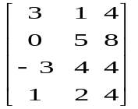  OR  Define the linear dependent and independent vectors, and verify that the vectors (1, 1, -1), (-1, 1, 1), and (1,-1, 1) are linearly independent or not. | 7
 | - Show that  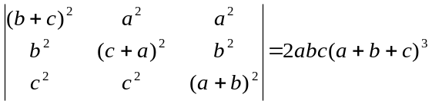 | 8
 | - Define consistency of the system of linear equations. Solve the given system of linear equations x + 3y + 6z = 23, x – y + 4z = 9, x – 4y + 2z = 7 by using Gauss Elimination methods.  - Define eigen value and eigen vector of the square matrix with characteristics equation. Find eigen value and corresponding eigen vectors of: 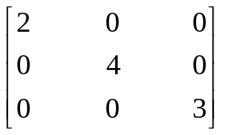 | 8  7
 | - Show that a necessary and sufficient condition for a vector function of a scalar variable to have a constant magnitude is 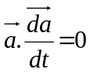  - Define gradient of a scalar function. If 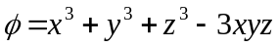, find  - 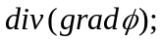and  - 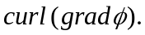 | 7  8
 | - State Greens theorem in a plane. By using it evaluate 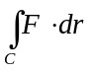, where 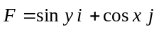 and C is the positively oriented triangle with vertices 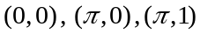.  - Evaluate the surface integral 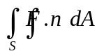 where 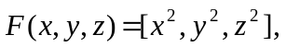 and S is the surface given by  .  OR  State Gauss divergence theorem. And evaluate the following using the Gauss divergence theorem:  where  = [1, xy, yz]  and S is the surface of x² + y² ≤ z, y ≥ 0, z ≤ 4. | 7  8
 | - Show that the infinite series 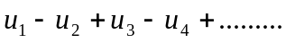, in which the terms are alternately positive and negative, is convergent if each term is numerically less than preceding term and 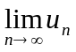  - Find the radius of convergence and interval of convergence of the series 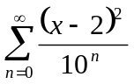  OR  Use Maclaurin's theorem to expand f(x) = 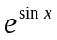 in powers of x. | 7  8
 | - Define periodic function with suitable example. Find the fourier series of the periodic function 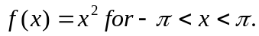 Using it show that 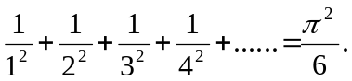  - Find fourier sine as well as cosine series of the function 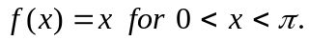 | 8  7
 | Short questions:  - Check the following transformation is linear or not  T:R² → R² be defined by T(x, y) = (x + 3, y)  - Test whether the series 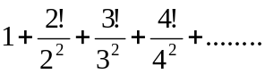is convergent or not.  - If 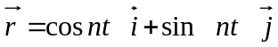, Show that 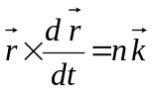  - Find a unit vector normal to the surface x²y + 2xz = 4 at (2, -2, 3)  - Find directional derivative of f = x² + y², at P(1, 1) along 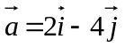 | 5×2

